Preliminary Design Review (PDR)
Project Name: Solar-Assisted Tilt-Rotor UAV for Low-Altitude Logistics
Course: Project in Design for Manufacturing (034371)
Group Number: 210
Group Members: Youwen Han / Wulin Xi / Zhuorui Yun / Xinlei Lin / Rui Zhong
Date: April 12, 2026

1. Concept Designs
During the brainstorming and concept development phase, our team explored multiple high-level ideas to address the specific operational pain points of modern logistics companies. The goal was to find a solution that offers both infrastructure independence (VTOL) and extended endurance.
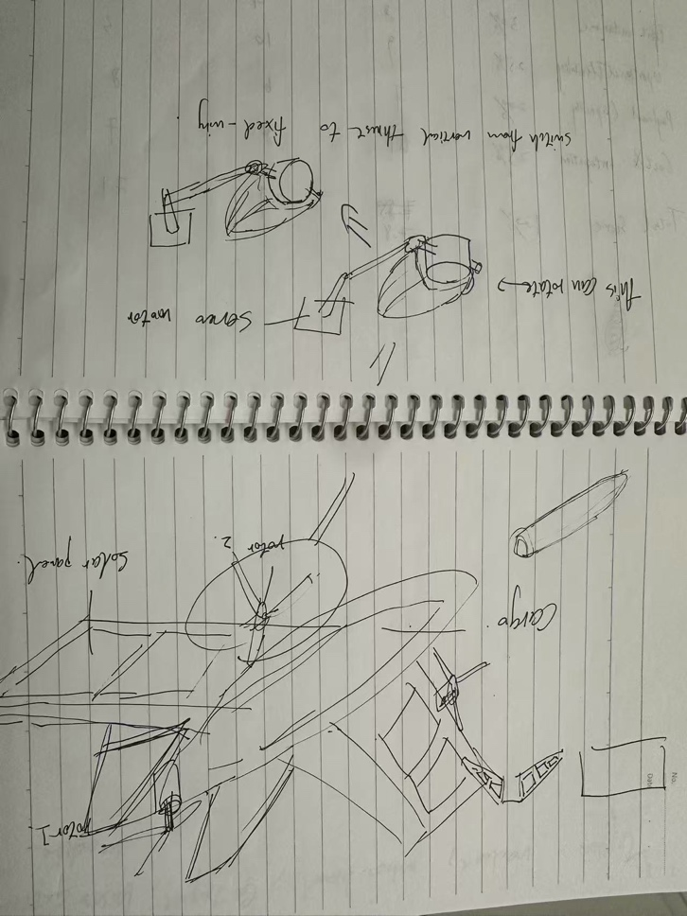
Figure 1. Draft of design
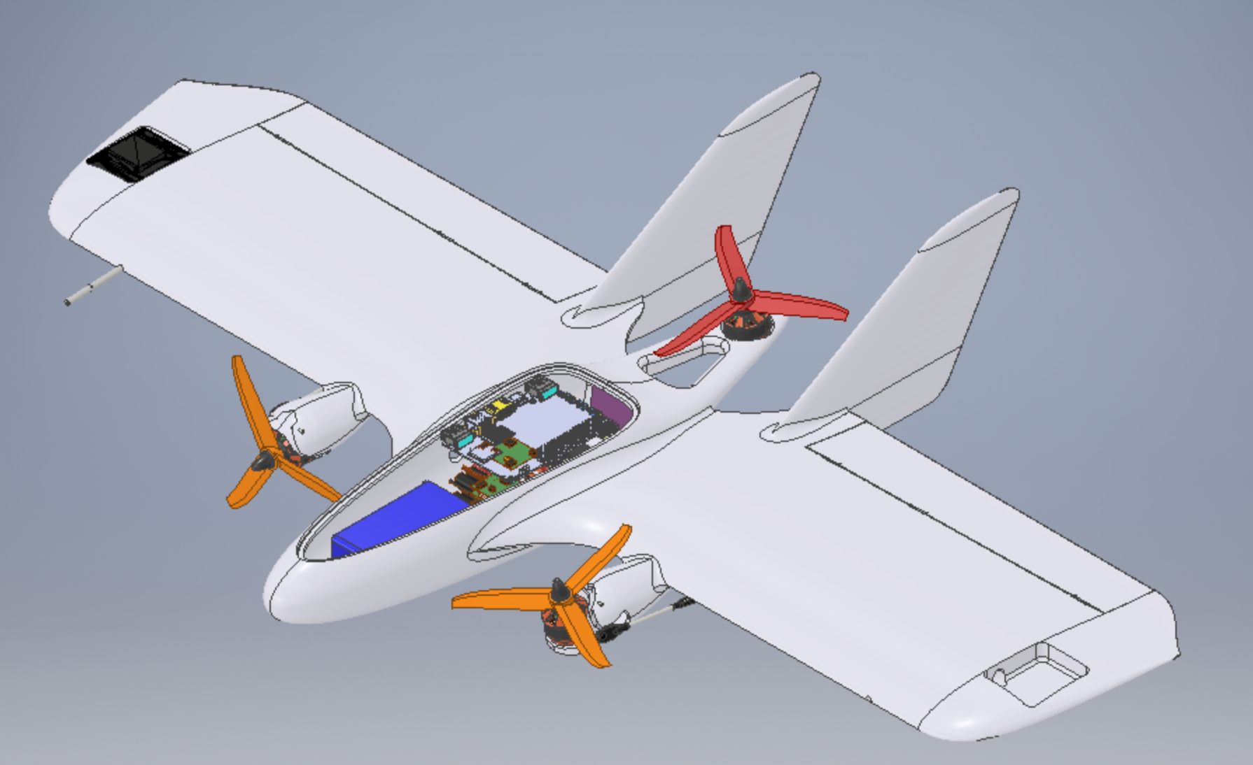

Concept A: Traditional Multirotor UAV with Extended Battery Pack
- Description: A quadcopter or hexacopter design focused entirely on vertical lift and hovering capabilities, with a maximized central battery compartment.
- Evaluation: This design perfectly meets the need for "Infrastructure Independence" as it can operate in highly constrained spaces without runways. However, due to aerodynamic inefficiency in forward flight, it fails to meet the "Endurance" requirement, restricting it to very short last-mile hops.

Concept B: Conventional Fixed-Wing UAV with Solar Panels
- Description: A standard fixed-wing airframe integrated with photovoltaic cells on the wing surfaces to harvest solar energy.
- Evaluation: This platform excels in "Endurance" and high-speed delivery over long distances. However, it completely fails the "Infrastructure Independence" requirement because it necessitates long runways, catapults, or bulky launch equipment, making it unviable for dense urban centers or rugged terrain.

Concept C: Solar-Assisted Tilt-Rotor VTOL (The "MiniHawk" Approach)
- Description: A hybrid aerial delivery platform integrating a tilt-rotor mechanism for vertical lift and forward flight, combined with photovoltaic energy harvesting technology on the wings.
- Evaluation: This concept performs vertical take-offs to satisfy infrastructure independence, then transitions into an aerodynamic forward-flight mode for efficient cruising. The integrated solar panels actively supplement power reserves mid-air to mitigate "range anxiety" and reduce charging downtime.

2. Concept Selection Process
The concept selection was conducted using trade studies to compare the proposed concepts based on weighted criteria derived directly from our System Requirement Review (SRR).

2.1 Evaluation Criteria & Decision Matrix
The primary evaluation metrics were derived from customer requirements:
- Endurance & Range (Mitigation of Range Anxiety) - 35%
- Infrastructure Independence (Flexibility/VTOL) - 35%
- Eco-Friendly & Sustainable Operations - 15%
- Manufacturing Feasibility & Cost - 15%
Criteria (Weight) | Concept A (Multirotor) | Concept B (Fixed-Wing) | Concept C (Tilt-Rotor)
Endurance (35%) | 3 | 9 | 8
Flexibility (35%) | 9 | 2 | 9
Eco-Friendly (15%) | 4 | 8 | 9
Feasibility (15%) | 8 | 7 | 6
Total Score | 6.0 | 6.1 | 8.2

2.2 Selection Rationale
Based on the decision matrix, Concepts A and B only partially met user needs, exposing a crucial market gap. Concept C (Solar-Assisted Tilt-Rotor VTOL) scored the highest and was officially selected for further development.
Justification: Concept C is the only solution that bridges the gap between operational flexibility and flight endurance. While its manufacturing feasibility is slightly more complex due to the moving parts, its ability to harvest solar energy during the highly efficient forward-flight phase addresses the critical unmet need of extended endurance, making it the most commercially viable and innovative product.

3. Technical Specifications
The success of the final design will be measured against the following preliminary technical specifications for the selected Solar-Assisted Tilt-Rotor UAV.

3.1 Material Specifications & Manufacturing
- Airframe Material: The primary airframe will utilize lightweight, durable composite materials (e.g., carbon fiber tubes for the main structural spars) to maximize payload capacity.
- Molded Components: Non-structural fairings and equipment housings will use ABS plastic for its durability and ease of molding.
- Geometric Considerations: Injection-molded plastic components will feature a uniform 3 mm wall thickness to prevent cooling warping, alongside 2° draft angles on vertical surfaces for easy mold ejection. Fillets and radii will be added to reduce stress concentrations.

3.2 Design for Assembly (DFA)
- Modularity: The UAV will feature a modular payload bay to quickly swap lightweight to medium-weight logistics packages, reducing operational downtime.
- Part Consolidation: Components will be designed to minimize assembly time, utilizing snap-fits instead of screws where structurally appropriate (e.g., access hatches for the flight controller).

3.3 Tilt-Rotor Mechanical Structure Subsystem (Core Innovation)
To achieve a smooth transition between VTOL and forward flight, the tilt-rotor mechanism is designed with strict DFM principles:
- Actuation Mechanism: High-torque, high-precision metal gear servo motors will be used as the tilt actuators. The design utilizes a direct drive or simple push-pull linkage system, adhering to part consolidation principles to minimize moving parts and assembly errors.
- Mechanical Stops: Based on failure analysis, hard physical mechanical stops will be integrated at the 0° (forward flight) and 90° (hover) positions to prevent over-rotation in the event of servo failure or signal loss.
- Rotating Shaft and Bearings: The main pivot shafts will be machined from 7075 aerospace aluminum. To reduce friction and lower custom manufacturing costs, standard off-the-shelf flange bearings will be used to support the tilt shafts.
- Tolerances and Fit: Critical mating surfaces within the tilt mechanism (e.g., shaft-to-bearing fit, servo spline connections) will maintain a strict tolerance of ±0.1 mm to prevent backlash and structural vibrations during flight transition.

3.4 Power & Energy Management
- Photovoltaic System: Thin-film, flexible solar panels will be laminated onto the upper surfaces of the main wings, ensuring minimal disruption to aerodynamic flow.
- Power Distribution: A smart power management system will be specified to seamlessly switch between battery draw (during high-power VTOL phases) and solar recharging (during low-power cruise phases).

3.5 Functional & Performance Targets
- Flight Paradigm: Full VTOL capability with mid-air transition to fixed-wing cruise.
- Payload Capacity: Target of 2 kg to 5 kg for standard medical or emergency logistics packages.
- Environmental Resistance: Operational in complex terrain without infrastructure; capable of withstanding light rain and moderate wind conditions (up to 20 km/h) typical of low-altitude environments.

